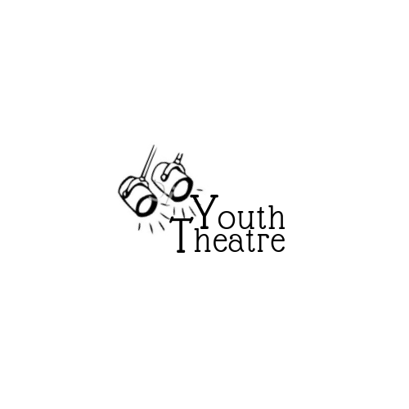  Theatre Summer Camp  performance  Ages 7– 17 Start Date - July 7th – July 12th 2025  Come and explore the excitement of performing on stage by learning drama skills and theatre knowledge, rehearsing & performing.  Limited enrollment.  Maximum class size – 18  The final class performance is open to the public (admission by donation) and parents, family and friends are welcome to attend.  Child’s First/Last Name  Age Grade  Parent/Guardian Name  Address  Home Phone Cell Phone  Email address  Fee: $150.00 per student  Cash / Cheque (payable to Wetaskiwin Theatre Society / E-Transfer to manluktheatre@telus.net  Questions? Call Emily at 780-312-4350 or email manluktheatre@telus.net | Instructor: Emily Yanosik  Camp is daily starting July 7th daily from 10-3  Please note:  - Camp will end in a final Variety show on Saturday, July 12th. Time of show TBD  MANLUK THEATRE FOR THE PERFORMING ARTS  5002 – 53rd Ave  Wetaskiwin, AB T9A 0Y7  780-352-8383  manluktheatre@telus.net  www.manluktheatre.com  About Emily  Emily is a MacEwan Graduate from the Music Theatre Performance diploma program. She has been involved in theatre for about 14 years and has been involved in many other musical performances. She is a youth musical theatre choreographer and acting teacher. She absolutely loves working with youth and cannot wait to teach this summer!




